**Strategy pane**

**What are the main goals of the site?**

To advertise the client’s business: building outside garden house/rooms. The site needs to be informative, but still leaving enough questions for them to book in a sales call/home survey. The site needs to gain top searches on Google in comparison to the competition. The site needs to have top quality design and finish – representative of the quality finish of the garden rooms.

**Who is the site for?**   
  
All clients need to be Hampshire based as that is the scope of the business. The majority of the customer base are over 50’s and/or retired. Another large group work from home.

**What content type would be relevant?**

Large font. Navigation always in site and simple – ie; fixed. Simple way to get in touch with regular CTA points. Everything should be obvious at first site. For example, I will state ‘Click here for more’ via the hover class over every image that is a link to another page.

**User needs and goals:**

The user needs this to research and compare with other sites. It needs to be informative enough to compare and enquire. They need to *trust* the business very quickly therefore reviews and accreditations need to be on the homepage.

**Business needs and goals:**

The business needs a higher number of enquiries. I will put a carousel of great reviews next to the enquiry form. Decrease enquiries that will never end in a sale. For example, people that don’t live in Hampshire, the word ‘Hampshire’ needs to be stated on the front page and in all key words.

**Competition sites:**

|  |  |  |
| --- | --- | --- |
| Site | Good | Bad |
| C-S Gardens | Regular CTA points Inspirational gallery In-depth ‘quick quote’ page |  |
| Future rooms | Slick design | No testimonials |
| Green retreats |  | Lots of Nav points cluttering the site. None of the links work |
| Dunster House |  | Way too busy and cluttered. Too many CTA’s Very salesy |

**What does the user expect?**

* What is this? Is it what I expected to see?

- Clear logo – large. Photo of work straight away and tag line of what the business does.

* Does it look credible and trustworthy?

- ‘Which trusted trader’, ‘10 year guarantee’, ‘Hampshire county council trading approved’ logos on the front page with testimonials and photos attached.

* Does it offer what I want?

- Photos, building options, reviews, links to other sites with more information ie ‘Which trusted trader’.

* Does it look valuable enough for me to stay and return?

- Very informative, will want to return due to ease of use.

* What actions can I take now?

- Enquire for a free survey.

* How do I learn more?

- Can follow links to other pages to increase credibility. Can enquire via the phone number given on contact us or the form on every page.

* How do I contact someone?

Via the form on every page or the ‘Contact us’ page with a mobile number if preferred.

|  |  |  |
| --- | --- | --- |
| Opportunity/Problem | Importance | Feasibility / Viability |
| Showcase portfolio | 5 | 5 |
| Increase social media presence | 2 | 5 |
| Increase brand awareness | 1 | 3 |
| Create more survey bookings | 5 | 5 |
| Higher google search results | 5 | 4 |
| Increase user interaction | 4 | 4 |

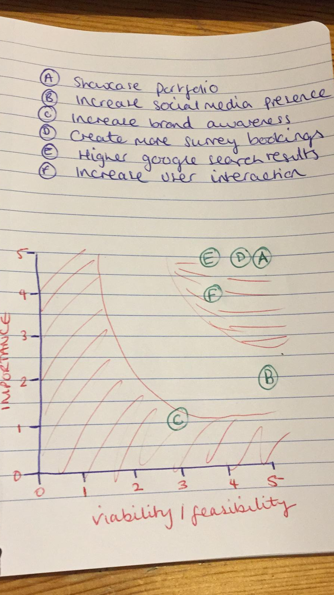

From the above table I will concentrate on showcasing his portfolio, increasing google search results, increasing user interaction and creating more survey bookings.